**Session 6a**

**12/05/2021**

**Problem Statement:**

**Explore the HDFS file system, Explore at least 15+ HDFS commands and prepare a report on it and upload it to the classroom.**

1. **Creation of a JAR file**

**Starting Hadoop single node cluster**

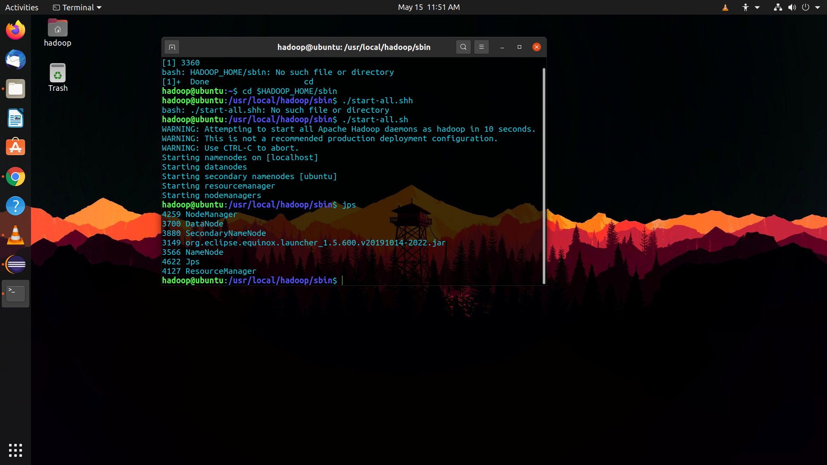

**First we create a project, a base class and two interfaces to show multiple inheritance**

**To create a JAR file:**

* Right click on the project
* Click on export
* Click on Java -> Inside Java click on JAR
* Select export destination and click next
* Click next again coming to the final window
* Here create a Main Class as it is required to navigate

**To access home directory of Hadoop:**

* $HADOOP_HOME = /usr/local/hadoop
* Root directory of Hadoop = / > /usr/local/hadoop
* Home directory of Hadoop = ~ > /home/hadoop/ => /usr/local/hadoop/home/hadoop

**Created base class and two interfaces to show multiple inheritance in Java**

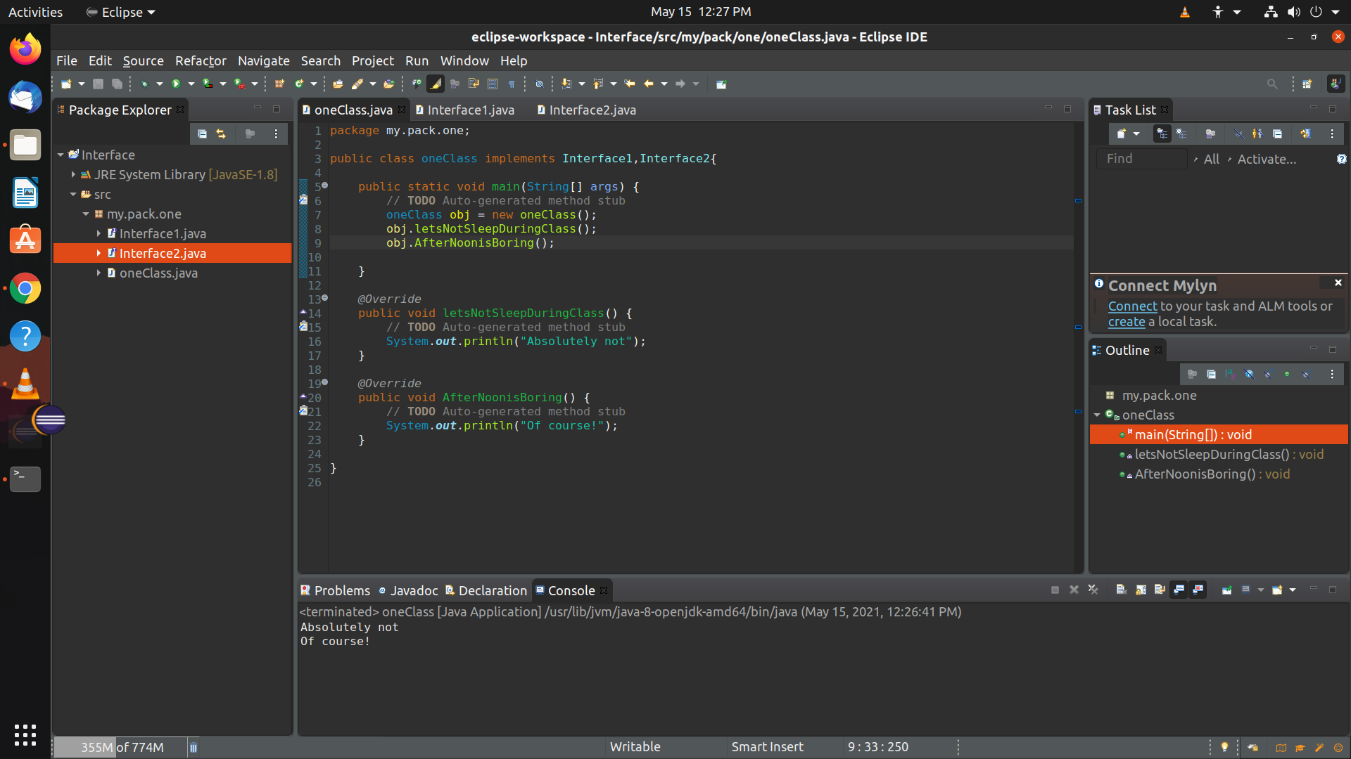

**Executed JAR file from terminal**

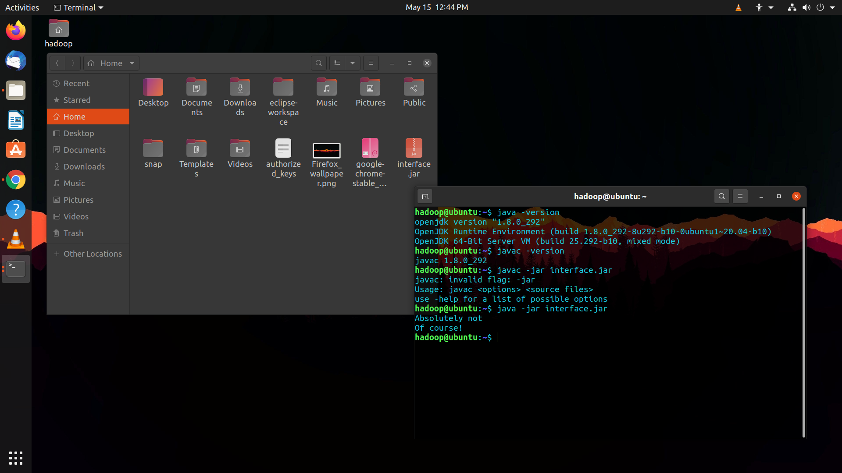

**General syntax of a hdfs command:**

*general pattern - $hdfs dfs(2.x)/fs(3.x) -commandname args*

1. **Playing around with Hadoop commands**

* $ hdfs fsck / (It checks file system integrity)

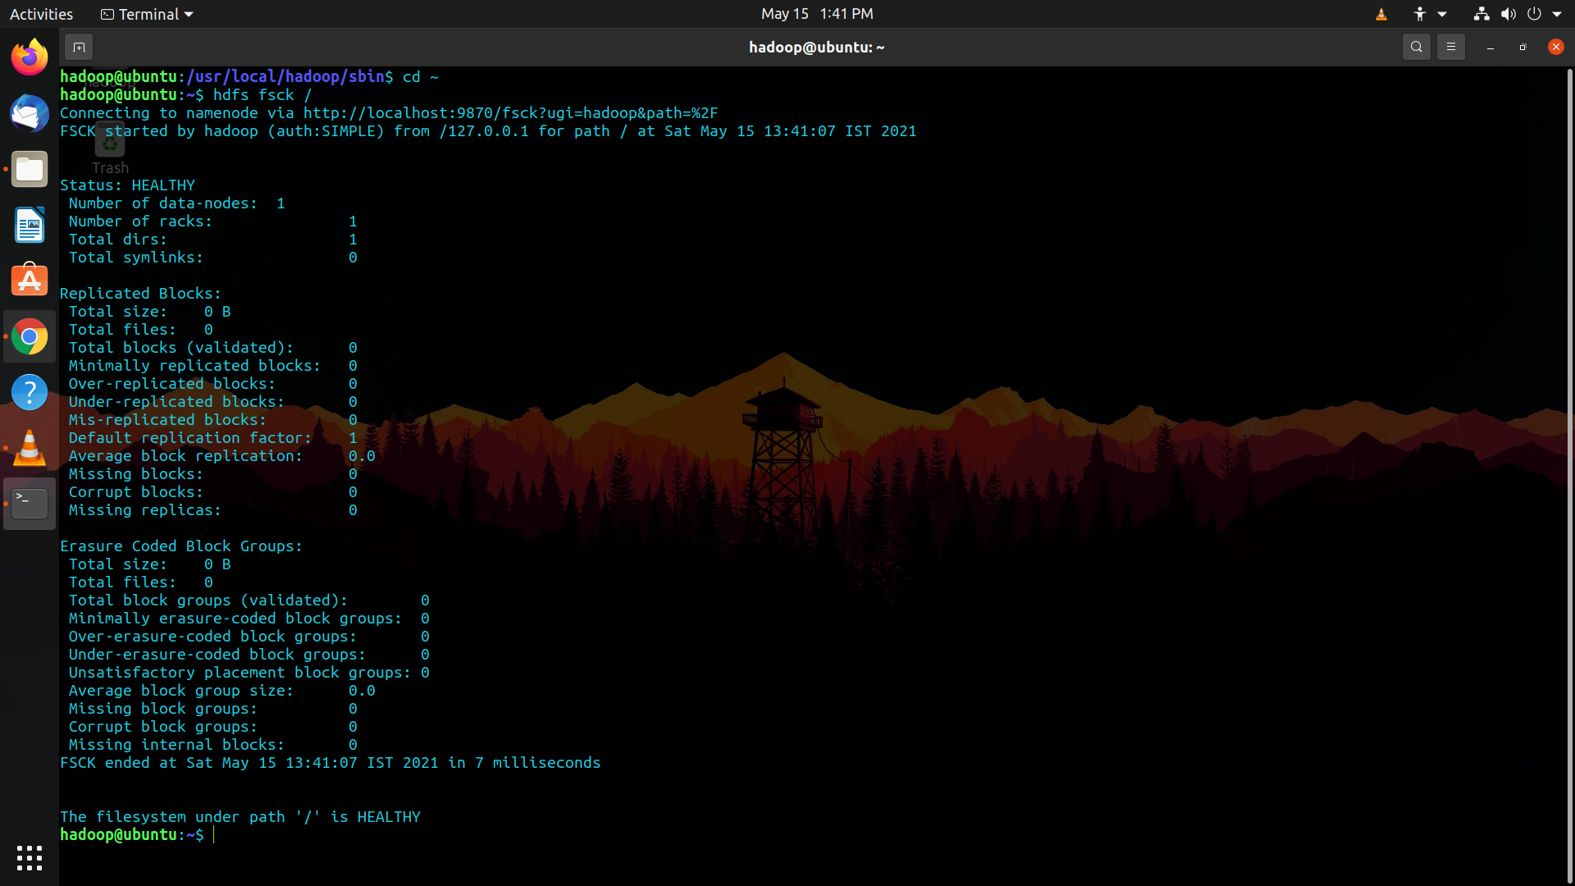

* $ hdfs dfs -df / (To check storage structure of Hadoop)

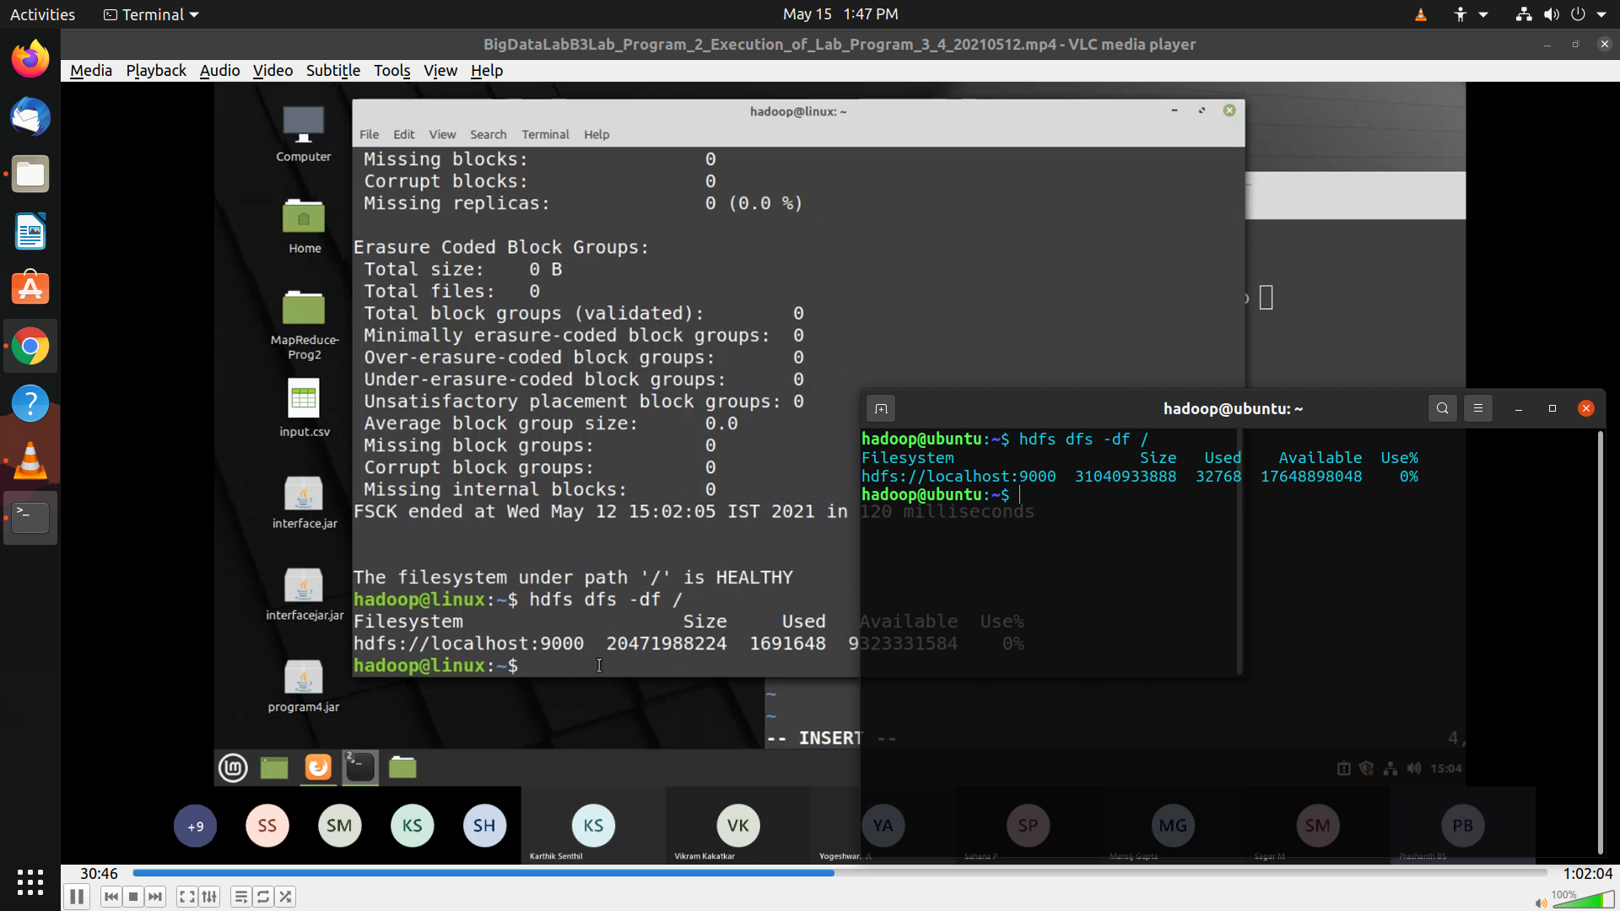

* $ hdfs dfs -ls ~/ (List all files in home directory)

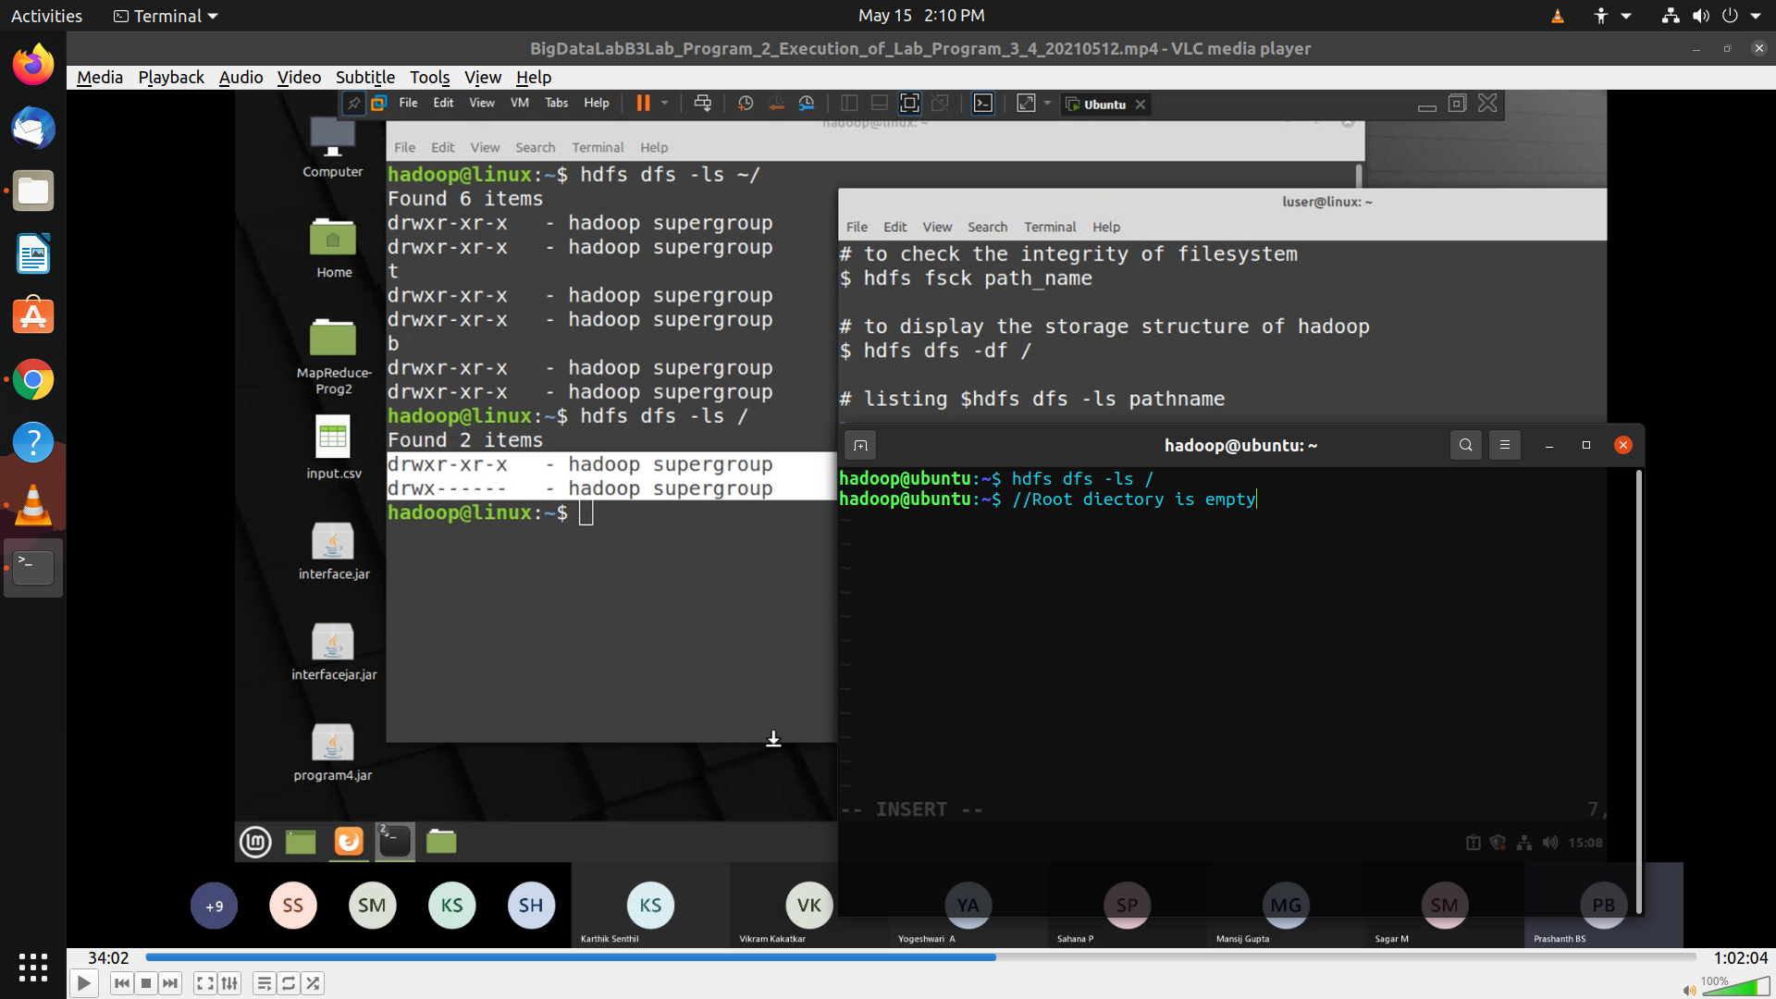

* $hdfs dfs -mkdir -p ~/myowndirectory (creates a dir. -p checks if dir already exists)

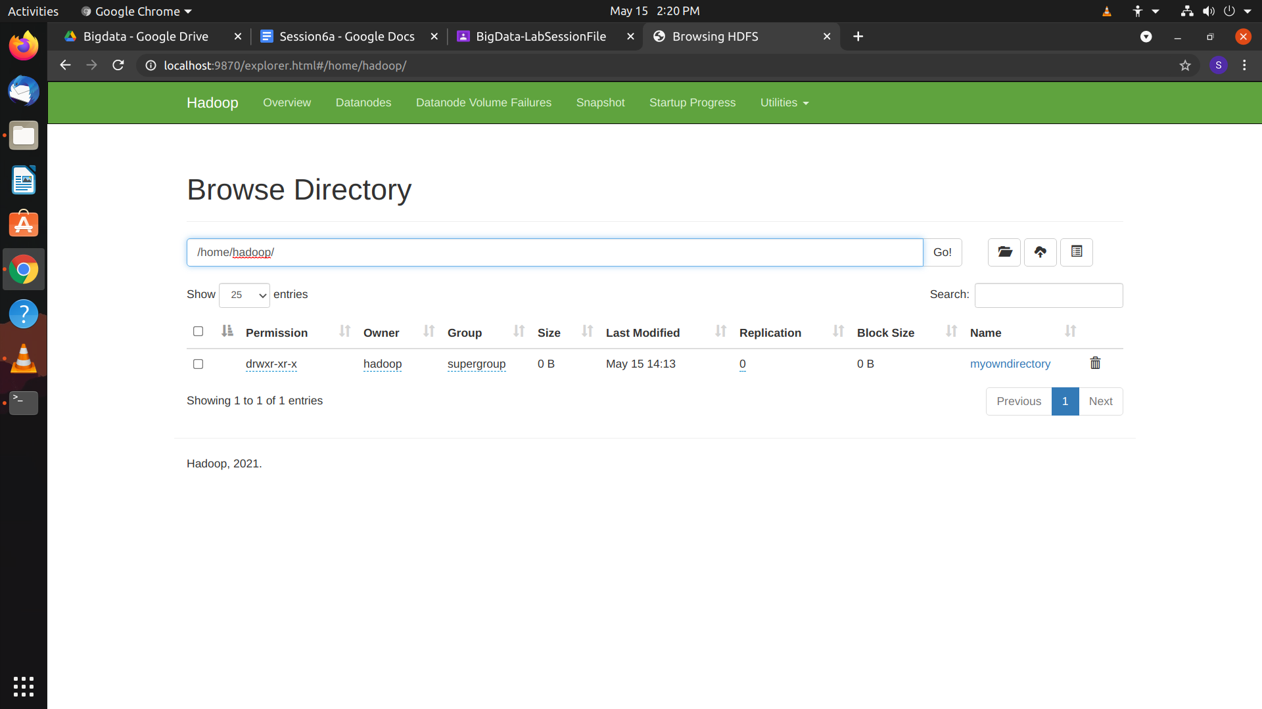

The directory has been created

* $ hdfs dfs -rmdir ~/myowndirectory (Deletes the directory)

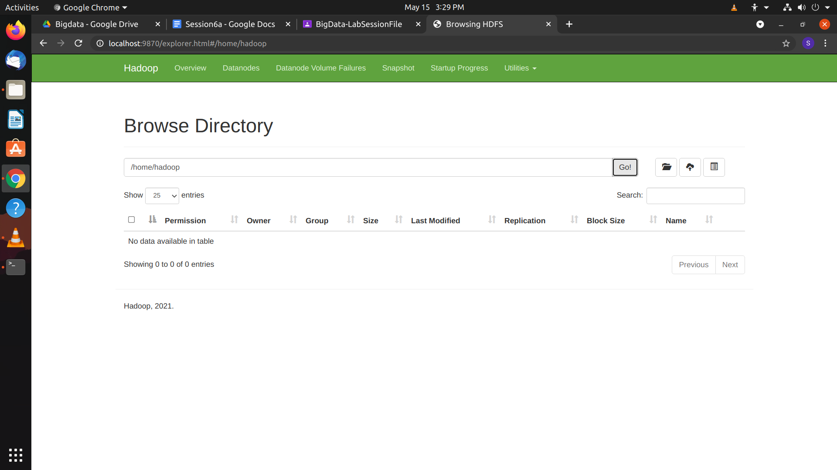

* $hdfs dfs -touchz ~/tempdir/in.txt (creates a new file in the directory)

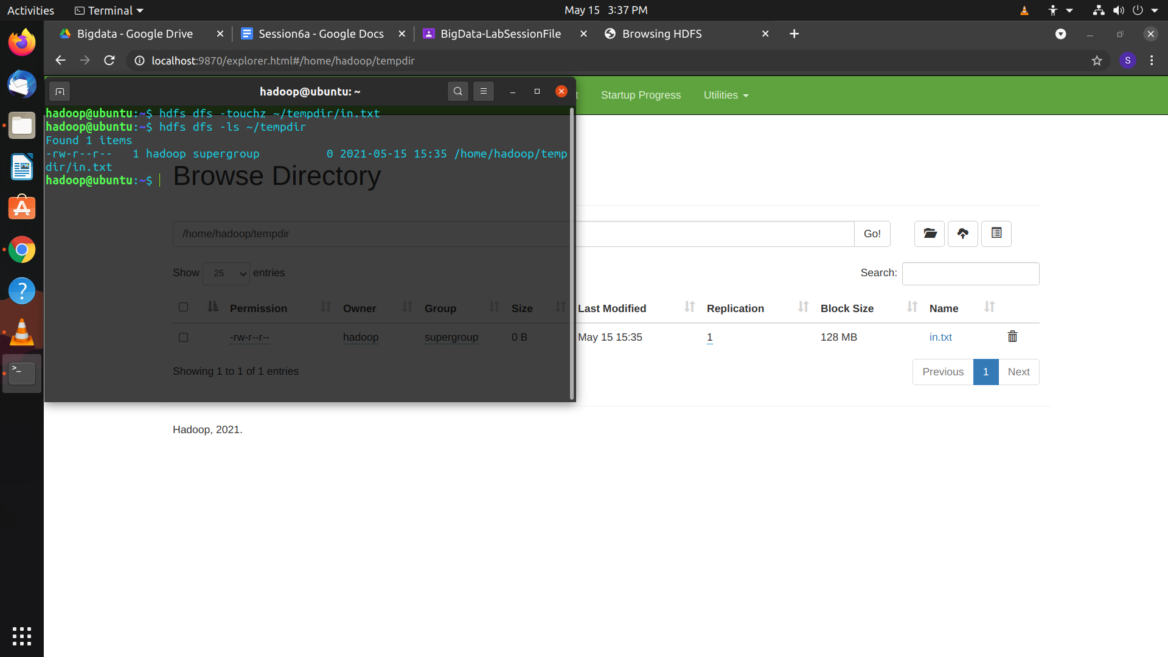

* $ hdfs dfs -appendToFile - ~/tempdir/in.txt (Adds content into file)

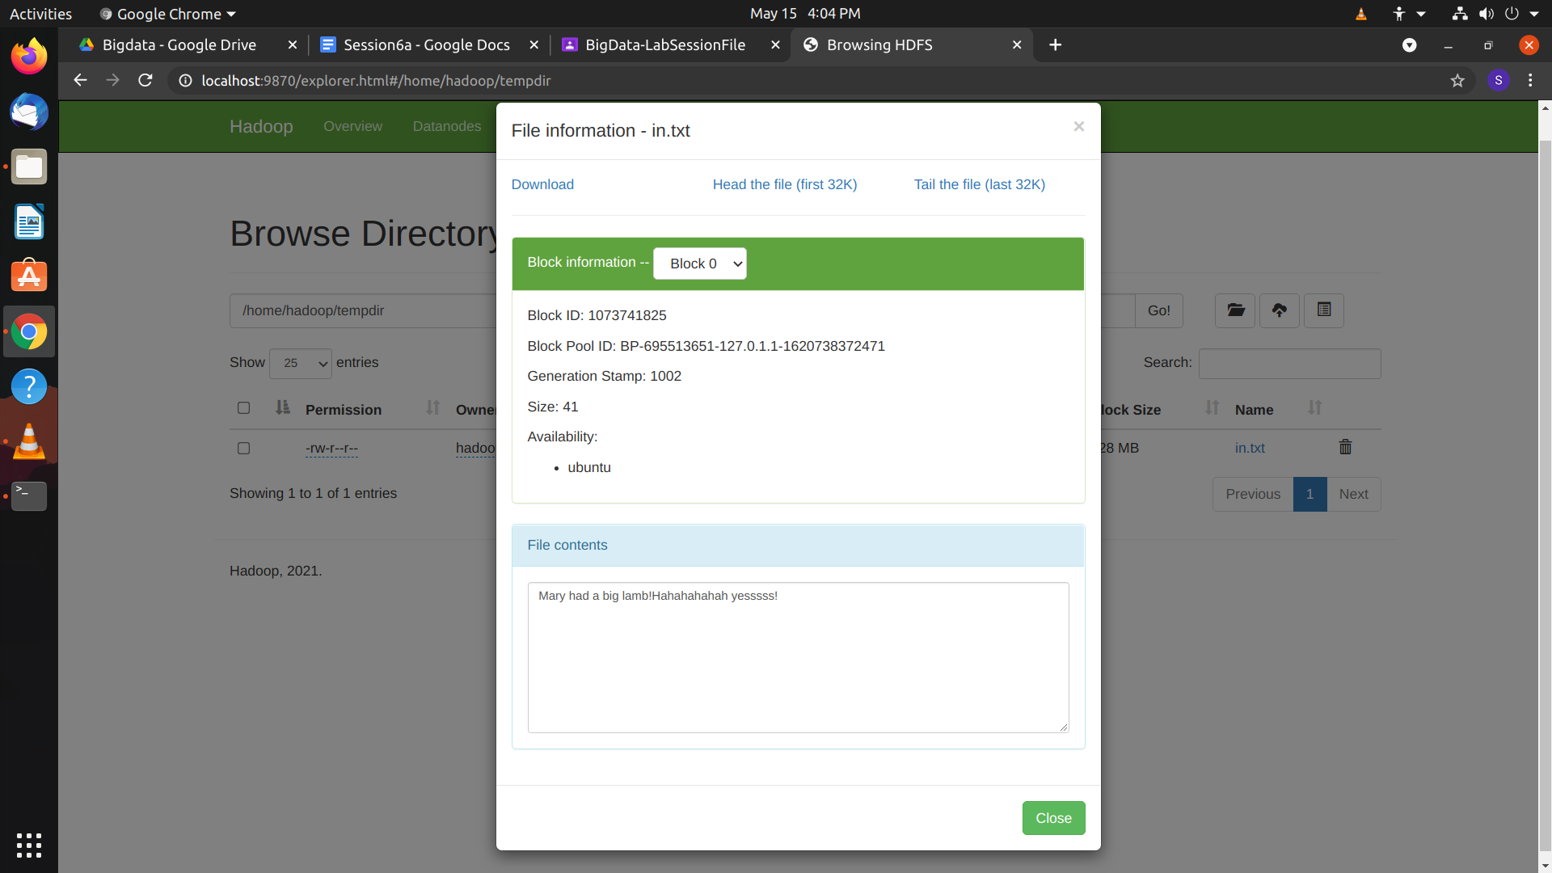

* $ hdfs dfs -cat ~/tempdir/in.txt (output whole file)
* $ hdfs dfs -head ~/tempdir/in.txt (output head)
* $ hdfs dfs -tail ~/tempdir/in.txt (output tail)

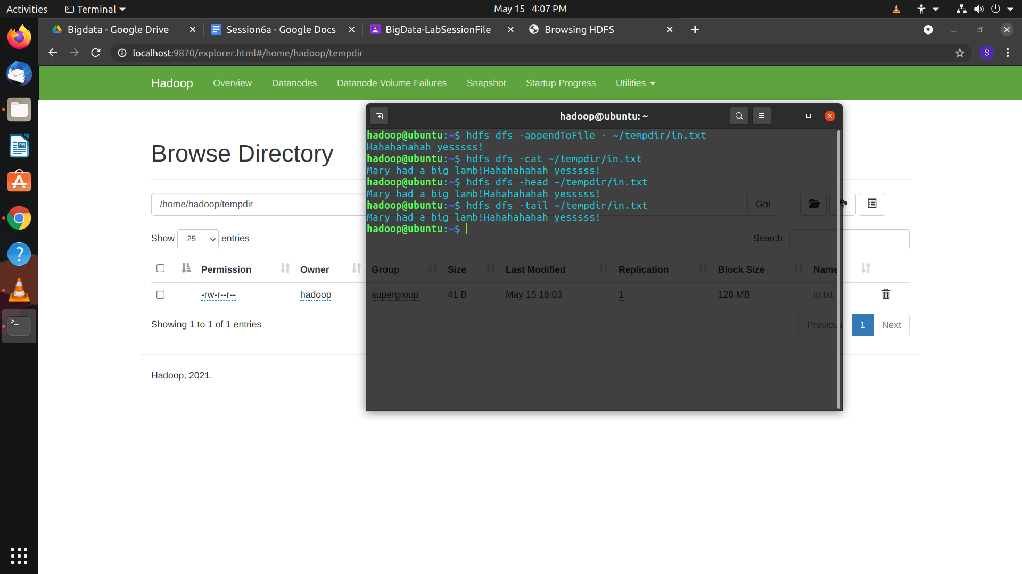

* $ hdfs dfs -cp ~/tempdir/in.txt ~/tempdirone (Copies from one dir to another)

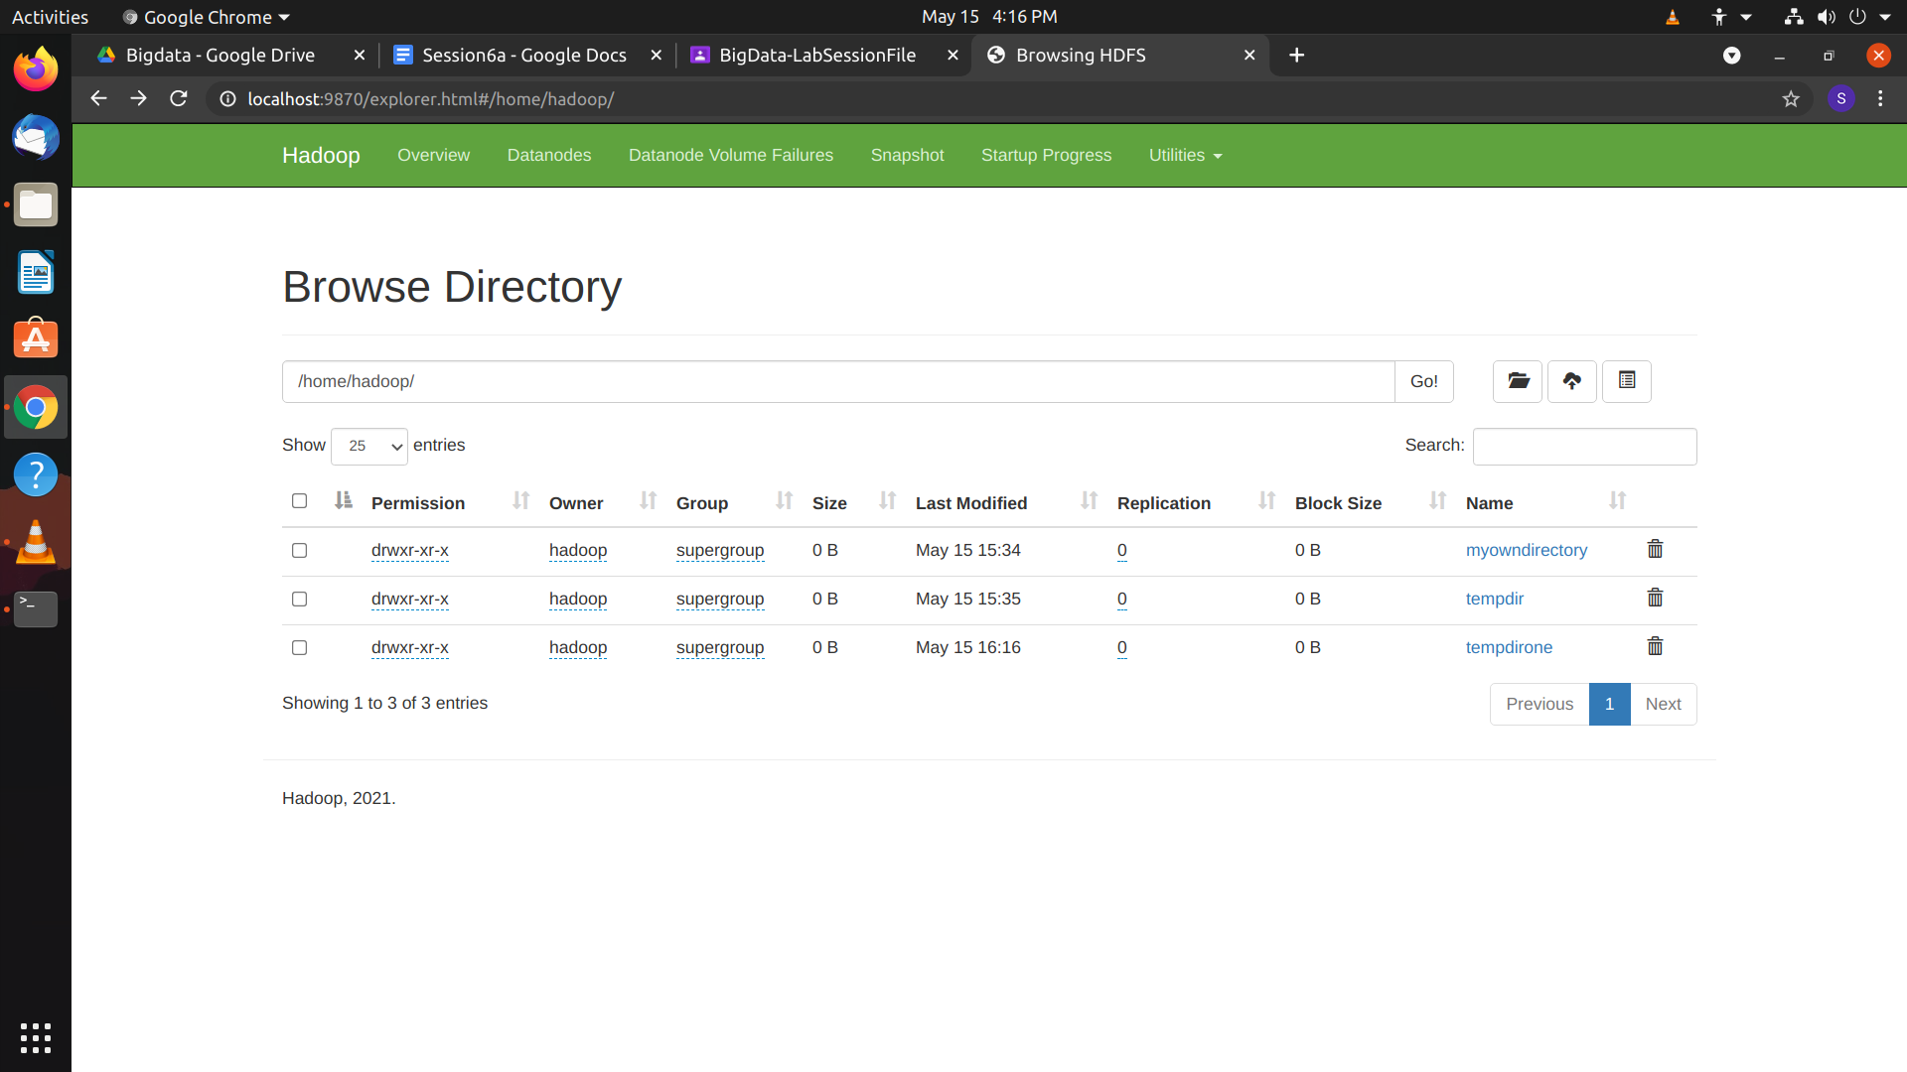

* $ hdfs dfs -rm ~/tempdirone/in.txt (delete file)
* $ hdfs dfs -mv ~/tempdir/in.txt ~/tempdirone (move contents from a to b)

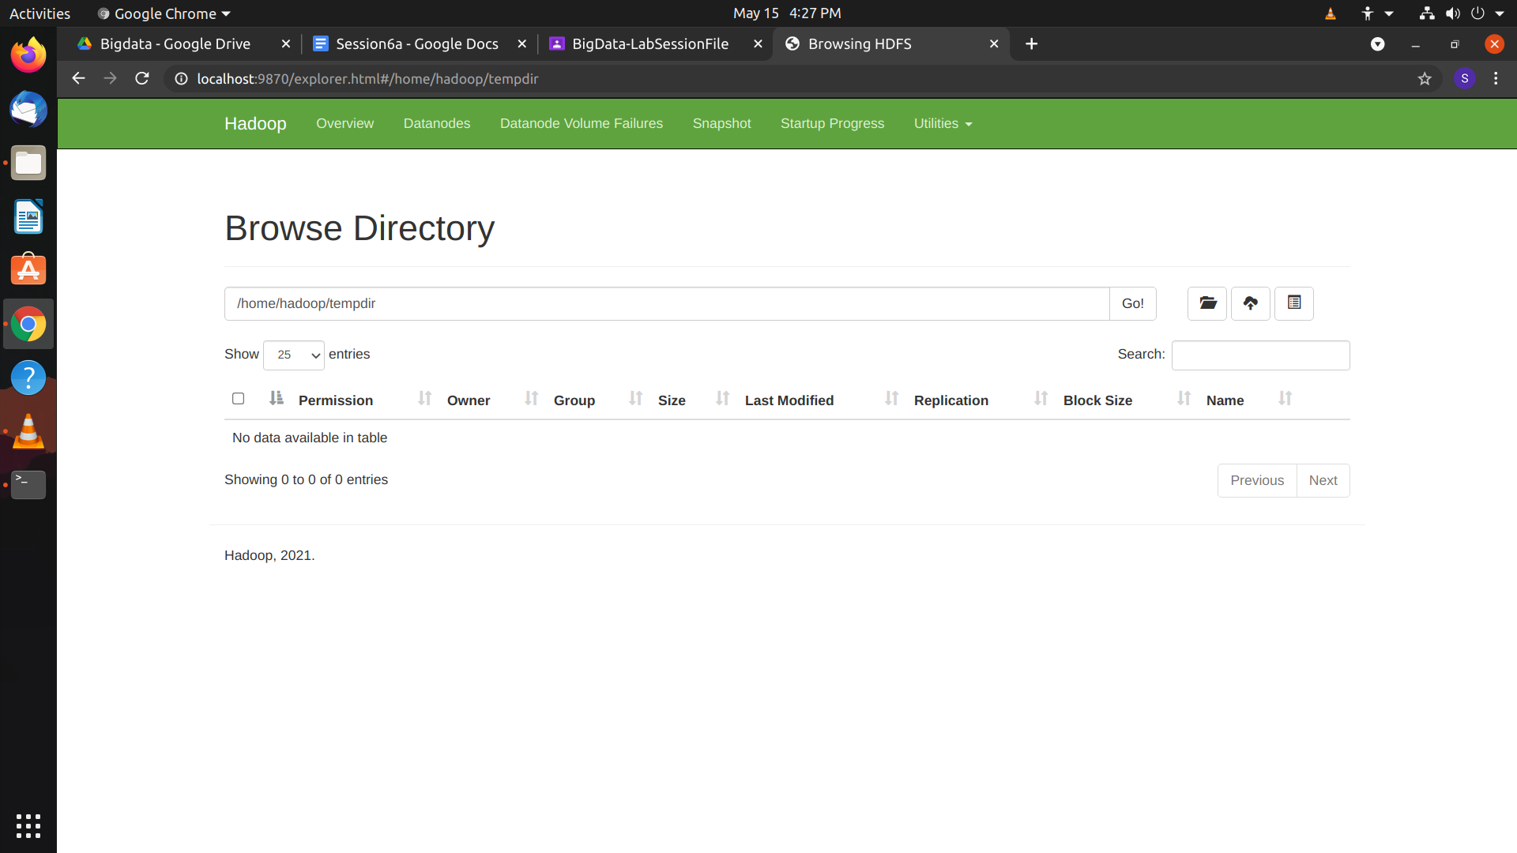

/home/hadoop/tempdir is empty

* $ hdfs dfs -mv ~/tempdirone/in.txt ~/tempdir/input.txt (used to rename file)
* $ hdfs dfs -copyFromLocal ~/dummy.txt ~/tempdir (from nfs to hdfs //nfs is linux file sys)

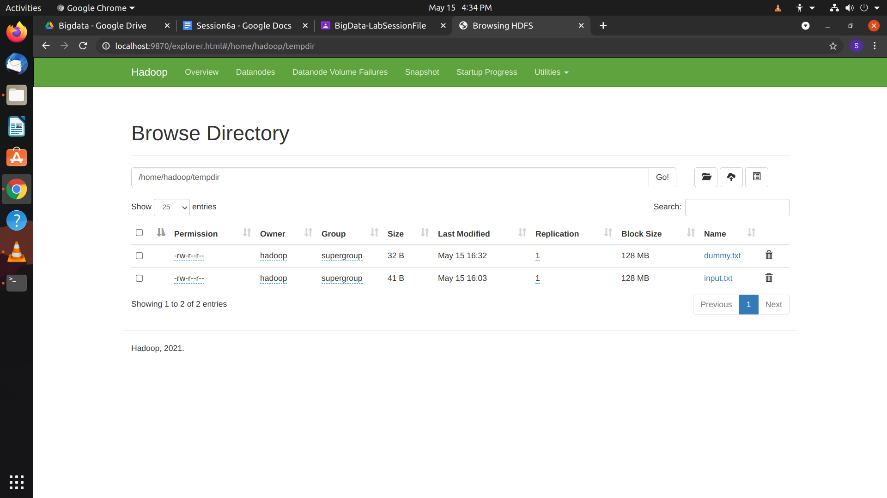

* $ hdfs dfs -put ~/dummy.txt ~/tempdir
* $ hdfs dfs -copyToLocal ~/tempdir/dummy.txt ~/
* $ hdfs dfs -get ~/tempdir/input.txt ~/

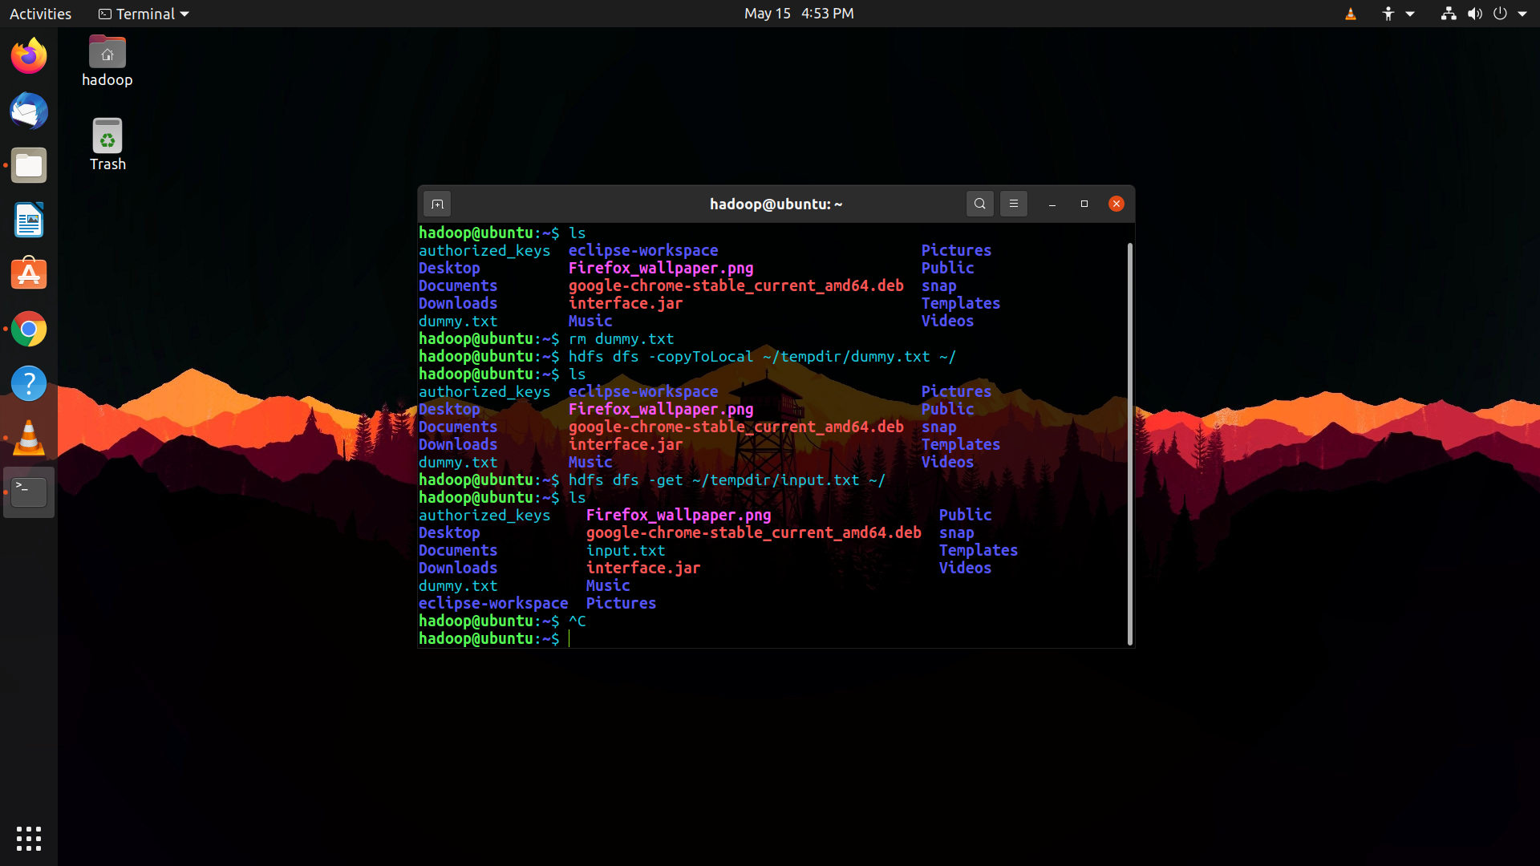

* $ hdfs dfs -usage get (Shows generic usage)
* $ hdfs dfs -help (Shows list of all commands in Hadoop)

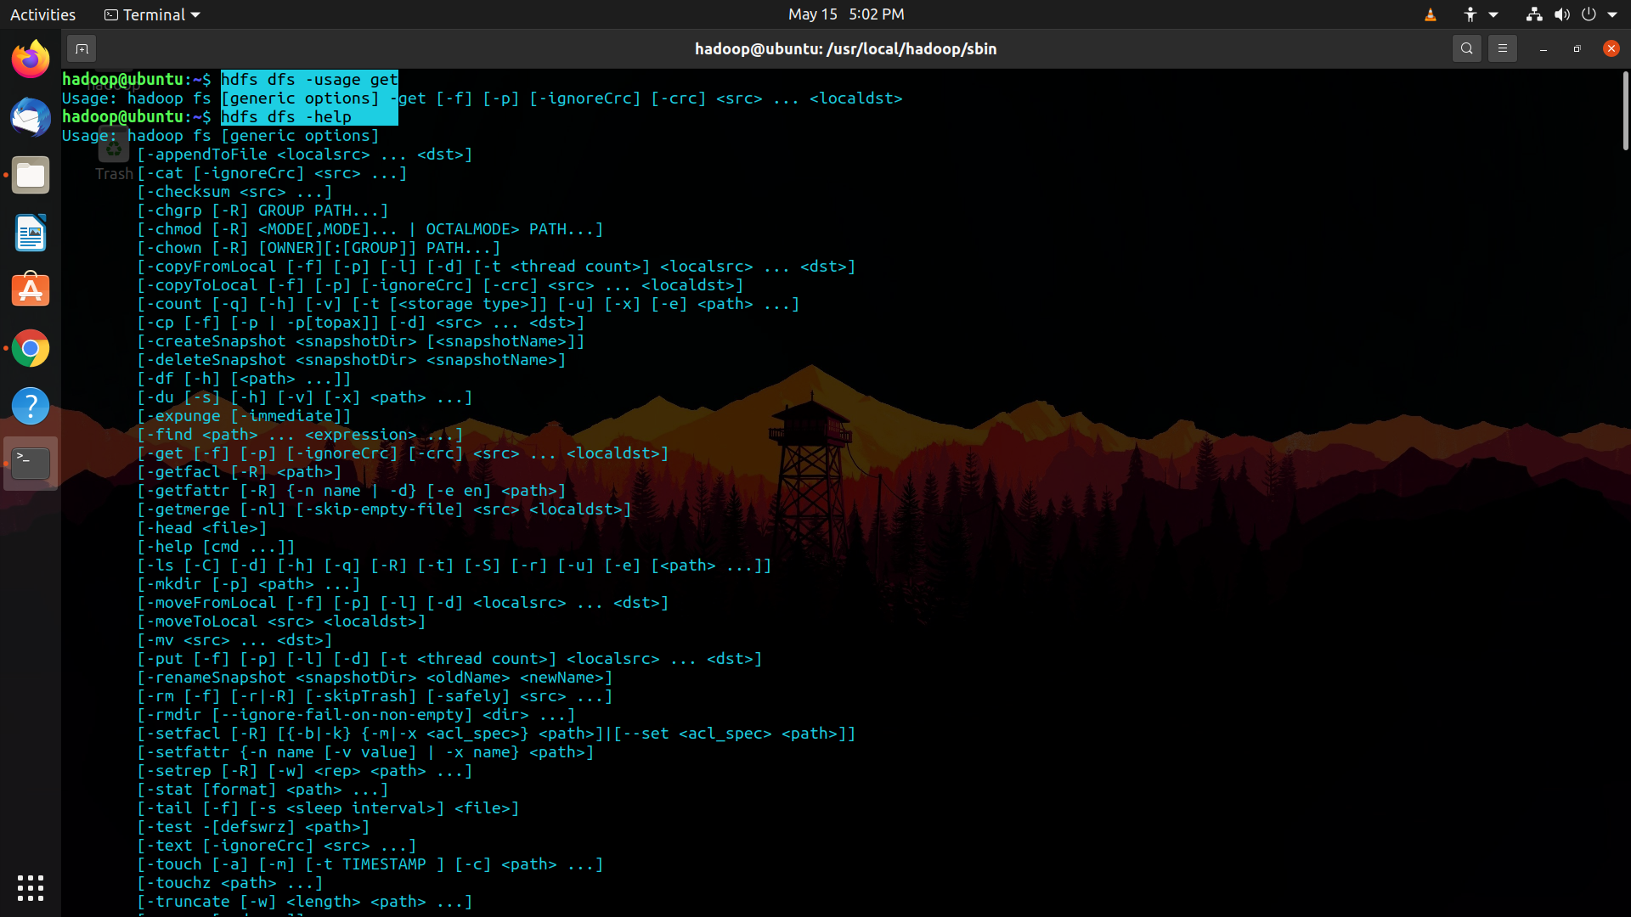

**Sriranjan S**

**1NT18IS159**